EXPERIMENT NO. 3
Implement Decision-Making and Branching Statements

PART B – TO BE COMPLETED BY STUDENTS
Roll No. C-60
Name Avdhut Parish Madhavi
Class / Division SE-C
Batch C2
Date of Experiment ________________________________________________
Date of Submission ________________________________________________
Grade ________________________________________________

B.1 Document Created by the Student
Run the program with service codes 1, 2, 3 and an invalid code, and record the outputs.
Input 1:
1
Output:
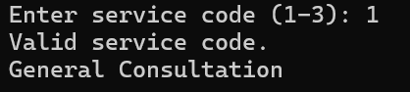
Input 2:
2
Output:
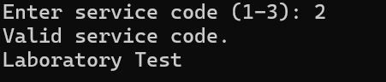
Input 3:
3
Output:
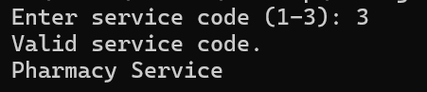
Input 4:
5
Output:
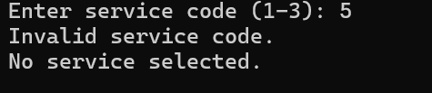

B.2 Student Program / Output
Paste/write the final program and attach or reproduce the observed output below.
import java.util.Scanner;

public class HealthServiceMenu {
public static void main(String[] args) {
Scanner sc = new Scanner(System.in);

System.out.print("Enter service code (1-3): ");
int code = sc.nextInt();

if (code >= 1 && code <= 3) {
System.out.println("Valid service code.");
} else {
System.out.println("Invalid service code.");
}

switch (code) {
case 1:
System.out.println("General Consultation");
break;

case 2:
System.out.println("Laboratory Test");
break;

case 3:
System.out.println("Pharmacy Service");
break;

default:
System.out.println("No service selected.");
}

sc.close();
}
}

Output:
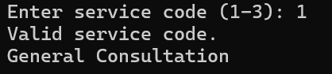

B.3 Observations and Learning
- When is switch preferable to multiple if-else statements?
The switch statement is preferable when a variable or expression must be compared against several fixed values. It makes the program easier to read and understand.

- What happens if break is omitted?
If break is omitted, execution continues into the next case, even if that case does not match. This is called fall-through.

- Why should input be validated before processing?
Input validation ensures that the entered value is valid and within the expected range. It helps prevent incorrect results and unexpected program behavior.

Student observation / learning:
The program uses an if-else statement to validate the service code and a switch statement to select the corresponding service. Valid codes display the appropriate service name, while invalid codes display an error message. The break statement prevents unwanted execution of subsequent cases.

B.4 Conclusion
Service names are illustrative examples aligned with the healthcare application theme.
Student conclusion:
The experiment demonstrated the use of if-else and switch statements in Java. The program successfully validated service codes and selected the appropriate service based on user input.

B.5 Questions of Curiosity
- When is switch preferable to if-else?
switch is preferable when selecting one option from multiple fixed values. if-else is more suitable for complex conditions involving ranges or multiple comparisons.

- What happens if break is omitted from a switch case?
Without break, execution falls through to the following cases until a break or the end of the switch statement is reached.

7. Why should input values be validated?
Input values should be validated to ensure they meet the expected requirements. This prevents invalid data from being processed and improves the reliability of the program.

